**CENWP-OD-B01 July 2024**

**MEMORANDUM FOR THE RECORD**

**SUBJECT: 24BON016 MFR AFF Valve 15 Pacific Lamprey Mortality**

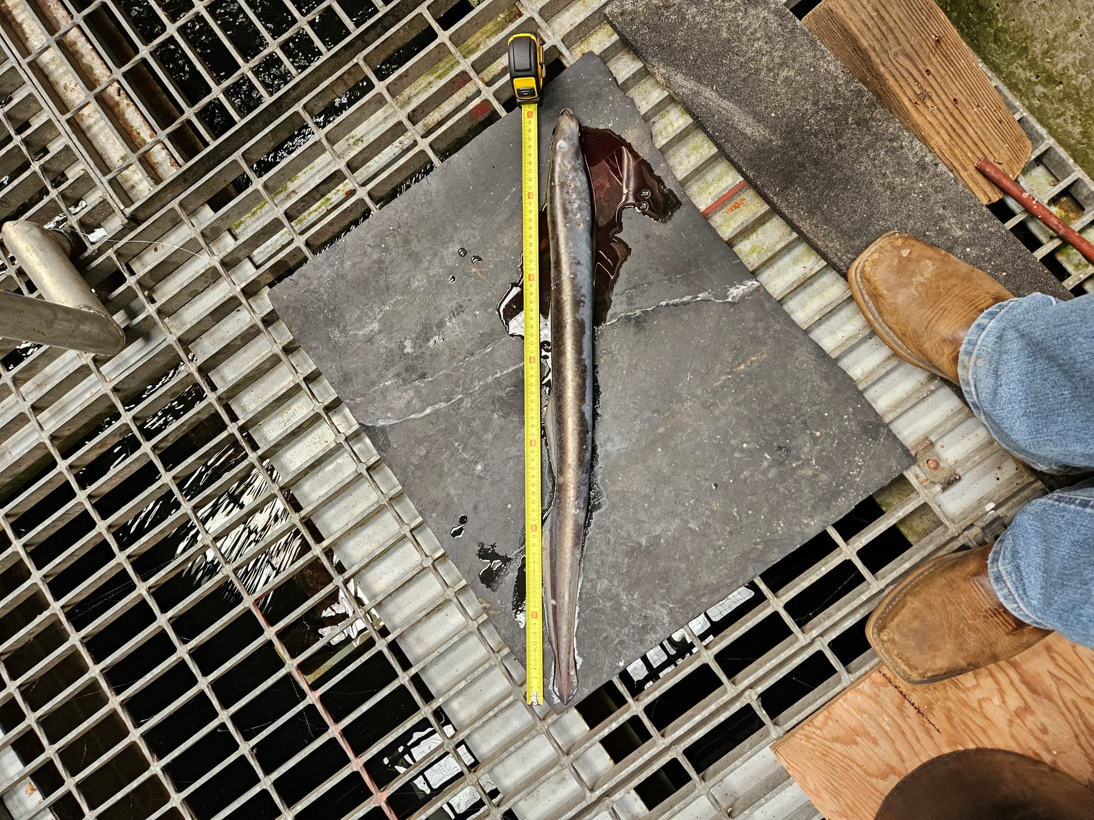On the morning of 02 July, Columbia River Inter-Tribal Fish Commission (CRITFC) Biologists notified Bonneville Project Biologists of one lamprey mortality found on the valve 15 trash rack in the Adult Fish Facility (AFF). The fish was scanned for PIT tags, inspected, and returned to the river.

1. Species – Pacific Lamprey (*Entosphenus tridentatus)*
2. Origin – Unknown
3. Length – 70 cm
4. Marks and tags – None
5. Marks and Injuries found on carcass – None
6. Cause and Time of Death – Unknown
7. Future and Preventative Measures – None

Sincerely,

Project Fisheries